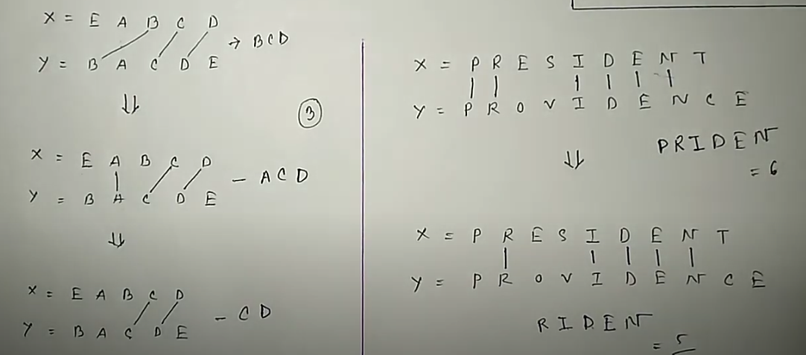

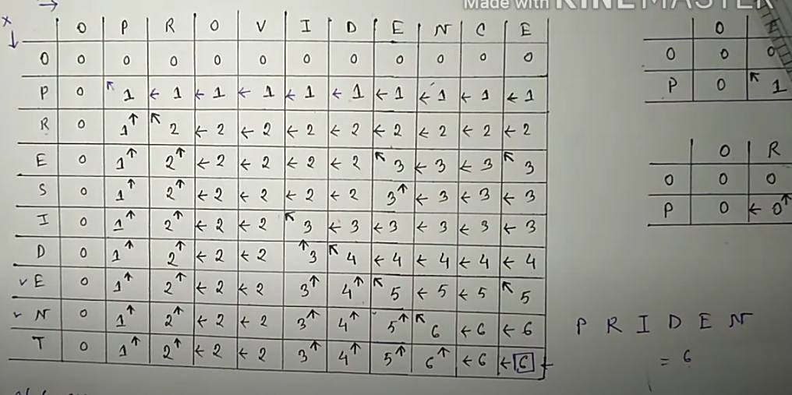
LCS Code:
#include <stdio.h>
#include <string.h>

#define MAX 100

int m, n; // lengths of strings x and y
int c[MAX][MAX]; // array to store lengths of LCS
char x[MAX], y[MAX]; // input sequences
char b[MAX][MAX]; // array to store direction ('c', 'u', 'l')

// Function to print the LCS using the 'b' array
void print(int i, int j) {
if (i == 0 || j == 0)
return;
if (b[i][j] == 'c') {
print(i - 1, j - 1);
printf("%c", x[i - 1]);
} else if (b[i][j] == 'u') {
print(i - 1, j);
} else {
print(i, j - 1);
}
}

// Function to compute the LCS and fill in the 'c' and 'b' arrays
void lcs() {
m = strlen(x);
n = strlen(y);

for (int i = 0; i <= m; i++)
c[i][0] = 0;

for (int j = 0; j <= n; j++)
c[0][j] = 0;

for (int i = 1; i <= m; i++) {
for (int j = 1; j <= n; j++) {
if (x[i - 1] == y[j - 1]) {
c[i][j] = c[i - 1][j - 1] + 1;
b[i][j] = 'c'; // 'c' indicates diagonal arrow
} else if (c[i - 1][j] >= c[i][j - 1]) {
c[i][j] = c[i - 1][j];
b[i][j] = 'u'; // 'u' indicates upward arrow
} else {
c[i][j] = c[i][j - 1];
b[i][j] = 'l'; // 'l' indicates leftward arrow
}
}
}
}

int main() {
printf("Enter the 1st sequence: ");
scanf("%s", x);
printf("Enter the 2nd sequence: ");
scanf("%s", y);

printf("The longest common subsequence is: ");
lcs();
print(m, n);
printf("\n");

return 0;
}

Output: Enter the 1st sequence: PRESIDENT
Enter the 2nd sequence: PROVIDENCE
The longest common subsequence is: PRIDEN

